**Introduction to React & TypeScript Building with Vite. Beginner Guide**

**5 different variants** of blog article ideas on using TypeScript in React, tailored for beginners:

1. "A Beginner’s Guide to Using TypeScript with React: From Setup to Deployment"

Outline:

* Introduction to TypeScript and why it's beneficial in React projects.
* Step-by-step guide on setting up a new React project with TypeScript using create-react-app or Vite.
* Building a simple functional component with TypeScript.
* Tips for managing types in props, state, and events.
* Conclusion with key takeaways and further learning resources.

2. "Top 5 TypeScript Concepts Every React Developer Should Know"

Outline:

* Introduction to the synergy between React and TypeScript.
* Detailed explanation of key TypeScript concepts:
  1. Interfaces for props.
  2. Generics in React components.
  3. Union and intersection types.
  4. Type inference in functional components.
  5. Handling React events with TypeScript.
* Practical code examples for each concept.
* Conclusion with a quiz or challenge for readers to practice.

3. "Building a Todo App in React with TypeScript: A Hands-On Project"

Outline:

* Introduction to the project and learning goals.
* Setting up the React + TypeScript project.
* Creating and typing components:
  1. Todo list.
  2. Add new todo form.
  3. Handling component state and props with TypeScript.
* Adding event handling and form validation.
* Finalizing the app and deploying it.
* Conclusion with a downloadable source code link.

4. "Common TypeScript Errors in React and How to Fix Them"

Outline:

* Introduction: Why TypeScript errors can be tricky for beginners.
* List of common errors with explanations and fixes:
  1. "Type '{ x: string; }' is not assignable to type..." – Misconfigured props.
  2. "Property 'y' does not exist on type 'X'" – Incorrect type inference.
  3. Event handling issues in forms and buttons.
  4. State initialization type mismatch errors.
  5. Using any too often and how to avoid it.
* Conclusion: How to debug TypeScript errors efficiently.

5. "How to Migrate a React Project from JavaScript to TypeScript (Step-by-Step)"

Outline:

* Introduction: Why migrate to TypeScript and its benefits.
* Prerequisites for migration.
* Step-by-step process:
  1. Installing TypeScript and updating configuration files.
  2. Renaming .js files to .tsx and fixing initial type errors.
  3. Adding types to props, state, and functions.
  4. Using TypeScript in context and hooks.
  5. Refactoring complex components with interfaces and generics.
* Conclusion with lessons learned and best practices for smooth migration.

**Intro v1**

Typescript is increasingly becoming essential tool and an industry standard in the web development. As a beginner who has a good grasp of React, adding TypeScript under your toolbelt will set you up for a success in your career or stand tall in your interviews. TypeScript is becoming increasingly popular among React developers because of the additional safety and tooling it offers. TypeScript essentially adds type-checking mechanisms in your code to enforce quality code, enabling you to catch errors early on during development without the need of you heading to the browser console and figure out the bugs during the run time. TypeScript also allow you to write self-documenting code, and improve code maintainability as well as easy refactoring of large applications. These are few reasons that you may want to consider when adopting TypeScript as initial investment in your code that pays off in the long run.

**Intro V2**

TypeScript is quickly becoming a must-have skill and a standard in the web development world. If you already have a solid understanding of React, learning TypeScript is a smart move—it can boost your career prospects and help you stand out in interviews. Many React developers are adopting TypeScript because it offers added safety and better tools for writing reliable code. By adding type-checking, TypeScript helps catch errors early, so you don’t have to spend time troubleshooting bugs in the browser at runtime. It also makes your code easier to read, maintain, and refactor, especially in larger projects. These benefits make TypeScript a valuable investment that will pay off as your projects grow

**Intro & hook Final**

TypeScript is quickly becoming a must-have skill and a standard in the web development. If you already have a solid understanding of React, learning TypeScript is a smart move, it can boost your career prospects and help you stand out in interviews. Many React developers are adopting TypeScript because it offers added type safety and better tools for writing reliable code. By adding type-checking, TypeScript helps catch errors early, so you don’t have to spend time troubleshooting bugs in the browser at runtime. It also makes your code easier to read, maintain, and refactor, especially in larger projects. These benefits make TypeScript a valuable investment that will pay off as your projects grow. In this article, I’ll walk you through how to use TypeScript with React, using practical examples. No prior knowledge of TypeScript is required, though a [quick overview](https://www.typescriptlang.org/docs/) can be helpful. I’ll keep the examples simple yet effective, guiding you step-by-step on integrating TypeScript into your React projects.

**Body v1**

**React project with TypeScript using Vite**

Let’s get started by setting up our React & TypeScript project by using vite. If this is your first time hearing about vite. Think of [Vite](https://vite.dev/) as your application's speedy assistant - it's a next-generation development tool that streamlines the process of building web apps, particularly React projects. Compared to traditional tools like Create React App, it offers a much more efficient and straightforward development experience.

**# Create a new React + TypeScript project**

To begin a new, React project with TypeScript using Vite, follow these steps:

1. First, create a new folder for your project. For example, name it "react-typescript"
2. Open this folder in your preferred code editor (like Visual Studio Code, WebStorm, etc.)
3. In your terminal, navigate to this folder and run this command:

npm create vite@latest . --template react-ts

Note: The dot (.) after "latest" tells Vite to create the project in your current directory instead of making a new one. This command sets up a React project with TypeScript support right away.

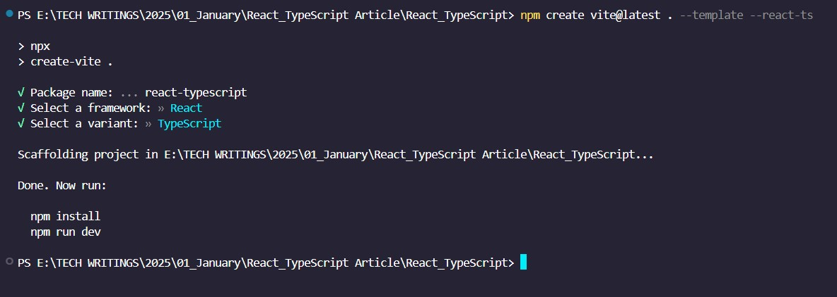

After creating your project, looking at your project structure I is likely that it looks like mine look like mine in the figure below, then you’ll need to install all the necessary packages:

1. Run this command in your terminal to install all dependencies:

npm install

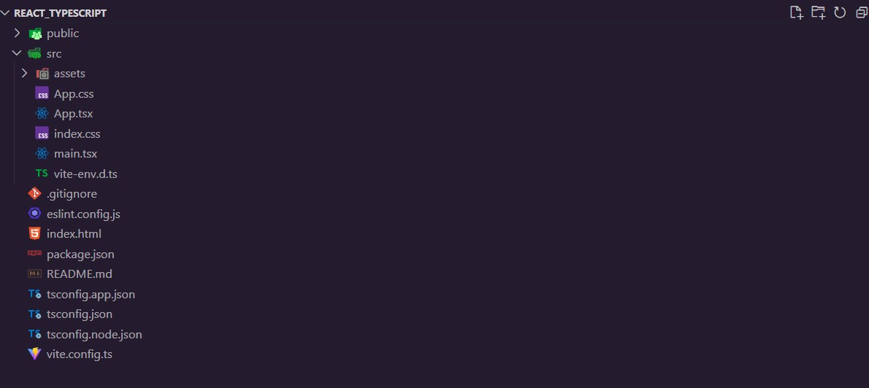

If you've used Create React App before, you'll notice Vite organizes files a bit differently. While the folder names might look different, you'll find all the familiar React files you're used to working with. The core functionality remains the same – it's just arranged in a slightly different way.

🎉 Congratulations! At this point, you've successfully created a new React application with TypeScript using Vite. Your development environment is now ready to go.

Time to see your app in action! Open your terminal and type:

npm run dev

This command starts up your development server. Once it's running, Vite will show you a local URL (usually <http://localhost:5173>) where you can view your application in the browser. Any changes you make to your code will automatically appear in real-time thanks to Vite's fast hot module replacement.

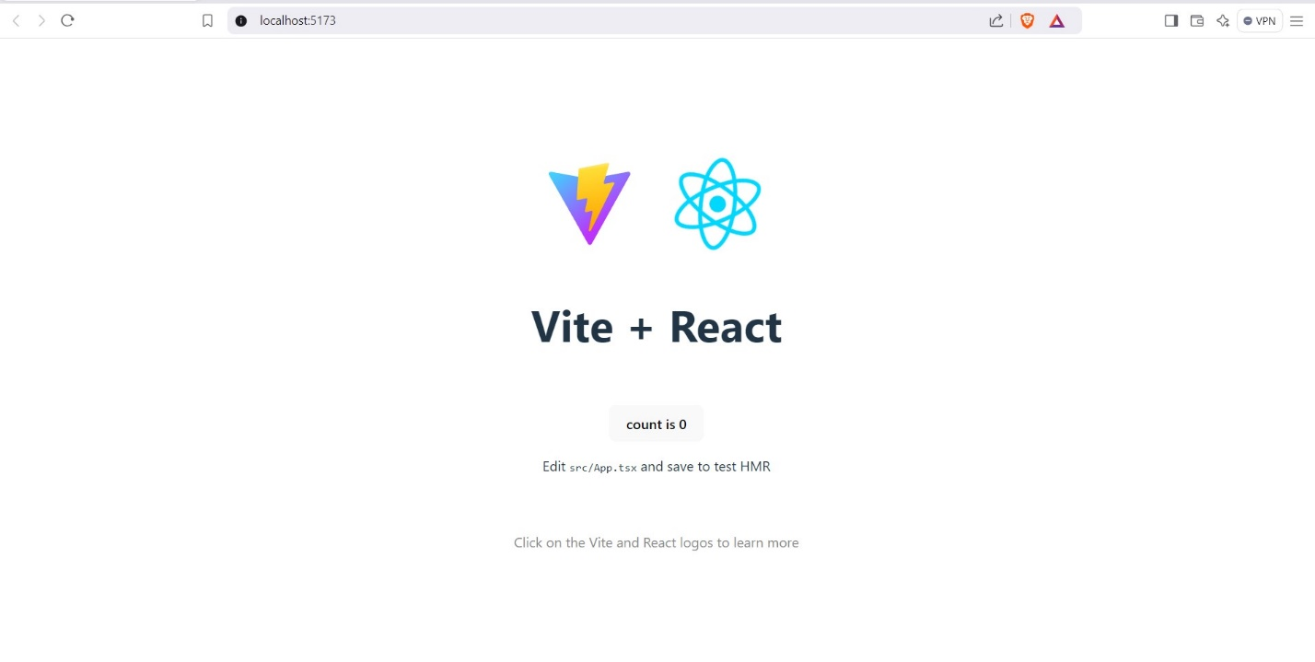

**Conclusion**

Mastering TypeScript alongside React can significantly enhance your web development career prospects. As more companies adopt TypeScript for their complex React projects, having this skill combination makes you particularly attractive to employers.

Coming up next, we'll dive into practical TypeScript implementation in React applications. You'll learn how to:

* Create functional components using TypeScript
* Handle typing for props
* Manage state with proper type definitions
* Type event handlers effectively

This hands-on knowledge will serve as your stepping stone toward developing robust, enterprise-grade React applications. Stay tuned to start building real-world components with type safety!